**Thermofluids Level5**

**Tutorial 7**

1. Why is a throttling valve used instead of an isentropic turbine in the ideal vapour-compression refrigeration cycle? Show the two processes on a T-s diagram, and discuss the effect on COP

Sol .

In VCRS the purpose is to get required condition of refrigerant at evaporator inlet. In order to achieve this we have to expand the liquid refrigerant coming out the condenser.

There are two available processes by which we can do this

1. Isentropic expansion
2. Isenthalpic expansion

In isentropic expansion process we will get some work output from expansion device si the net system work required is decreased but the main problem is that, the expansion work available in isentropic expansion is too small as pressure ratio in the VCRS cycle (Condenser pressure/Evaporator pressure) is less also the complexity and cost associated to achieve isentropic expansion are too more. So we use isenthalpic process for expansion as it can be easily achieved using throttling (which result ub great reduction in cost and complexity with compromise in reduction of work).

Throttling process: Pressure reduces, No heat and work interactions, Enthalpy remains constant

In VCRS, condition of refrigerant is inside the vapor dome (in two phases) after throttling from condenser outlet. Throttling reduces pressure at constant enthalpy and condition of liquid refrigerant from condenser outlet changes to mixture of liquid and vapor at evaporator inlet as it is inside the vapor dome.

If we note there is no heat transfer in throttling process but the liquid refrigerant becomes mixture of its vapor and liquid phase. In such vaporization latent heat is absorbed from refrigerant itself so temperature of refrigerant reduces greatly along with that caused by pressure reduction.

Here throttling process fulfills both objectives (Reduction in pressure and temperature) very easily and economically (more important) as compare to isentropic expansion process so it is used in VCRS.

Vapor Compression Refrigeration system T-s diagram

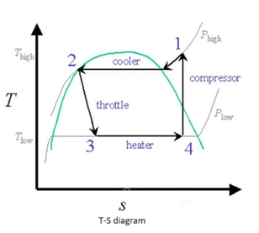

To improve the coefficient of performance, it requires that the compression work should decrease and refrigeration effect should increase. It means that decrease in condenser pressure and temperature so refrigeration effect will increase and compressor input work due to this COP will increase.

1. A refrigerator has working temperatures in the evaporator and condenser coils of -30 and 32 °C respectively. What is the maximum COP possible?

If the actual refrigerator has a COP of 0.75 of the maximum, calculate the requiredpower input for a refrigerating effect of 5kW.

Sol.

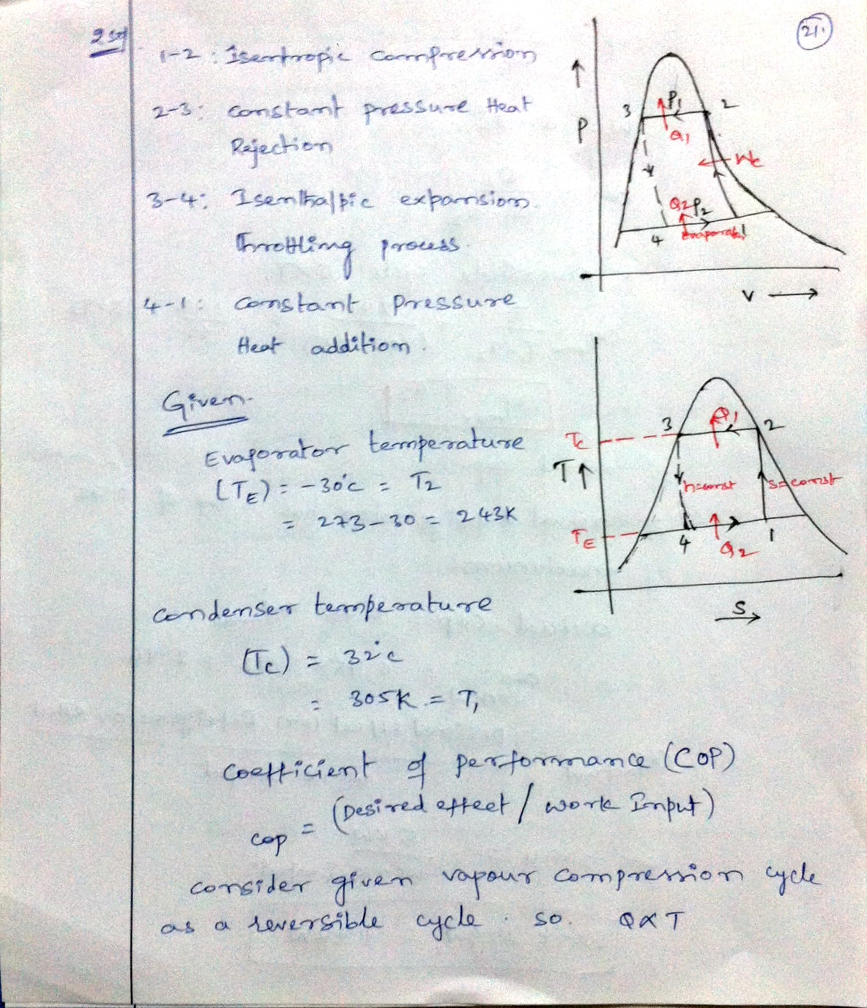

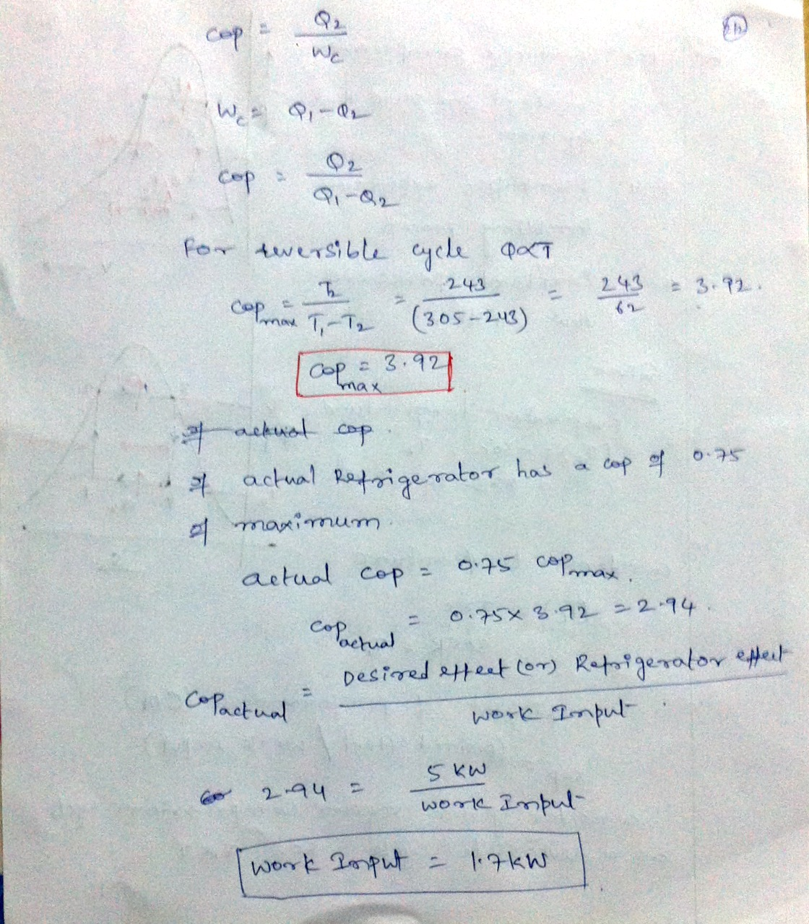

1. A refrigerator uses refrigerant-12 as the working fluid and operates on an ideal vapour-compression refrigeration cycle between 0.14 and 0.8MPa. If the mass flow rate of the refrigerant is 0.05kg/s, determine (a) the rate of heat removal from the refrigerated space and power input to the compressor, (b) the heat rejection rate to the environment, and (c) the COP of the refrigerator. Use tables for refrigerant-12.

Sol.

